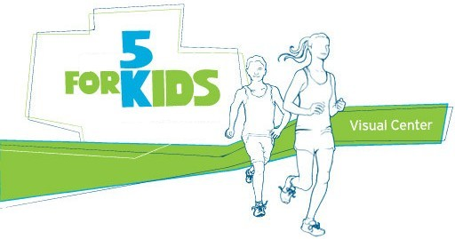
Race
the
May 18, 2019

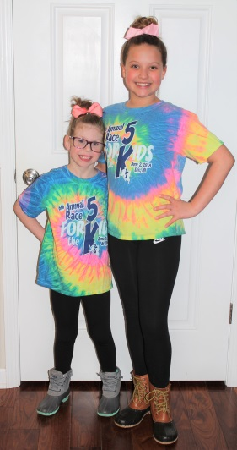
7th Annual Race for the Kids
Throughout the 6 years that our organization has held The Race for the Kids, we have been able to help 9 different families through medical and financial struggles. Because of your support, this race has become a great success. Come join us Saturday, May 18th at St. Joseph’s School in Erie for a 5K run/family walk through Erie. All proceeds will be used to help local families with children who are suffering from severe or life threatening medical issues. The cost is $25 each or $75 for a family of up to 5 people. This event will be from 8am-11am. It will have fun activities for people of all ages (moonwalk, face painting, cardio drumming, silent auction, raffles and snacks). Come join us for a great day that will help benefit a wonderful community cause. More information is available at www.erie5k.net or at our Facebook Page Race for the Kids.

Date: May 18, 2019

Time: 9AM Start of Race
Registration begins at 8AM and ends at 8:45AM

Location: St. Joseph’s School Gymnasium
2238 Manhattan St. Erie, MI
Enter off of Erie Road

Entry Fee: $25 ea. / $75 up to family of 5
Registration closed on May 4th.
$5 late fee if registering after May 4th
No family discount for late registrations

Course Description: 5k run/walk road course through Erie, MI
or Cardio Drumming

Age Groups: Male/Female 8 & under, 9-12,
13-19, 20-29, 30-39, 40-49, 50-59, 60+

Packet Pickup: Race day starting at 8am

All proceeds will go to local families with children who are fighting severe medical battles.

Fun for all Ages: DJ, Face Painting, Silent Auction, Cardio Drumming, Moonwalk, Raffles

Name | Address  (include city, state and zip) | Date of Birth (m/d/yr) | Sex  M/F | 5K(timed)  (X) | Family  Walk  (X) | Cardio Drumming | Shirt  Size*
* Guaranteed t-shirt to pre-registered runners/walkers/cardio drummers only. Toddler Sizes(2T,3T,4T)
Youth Sizes (YS/YM/YL/YXL) or Adult Size (S/M/L/XL/XXL)
MAIL ENTRIES OR DONATIONS TO: Race for the Kids 2299 Manhattan St. Erie, MI 48133
Make checks payable to: Race for the Kids
Waiver: By signing and submitting this entry form. I hereby, for myself, my heirs and my executors, waive and release all rights and claims for damages I may have against the City of Erie and their departments, sponsors and volunteers for injuries suffered b y me in this event.
Signature: Date Signed:
Guardian Signature (if under 18) :
Visit www.erie5k.net for on-line registration, to make a donation and for more information.

